**Description of the method**

The computational logic for the operation of the SLIC Superpixel method begins with the definition of the maximum number of K groups with approximately the same pixel size. For color images in the CIELAB space, the procedure starts with the step of defining the initial cluster centroid $C_{i}= \left[L_{i}a_{i}b_{i}x_{i}y_{i}\right]$ where $C_{i}$ are arranged in a regular G pixel grid. To generate SLIC Superpixels of approximate sizes, the G= √(N/K) where the centroids are located in a lower gradient pixel region, avoiding the centroid being close to the edge of the Superpixel or having a noisy pixel (ACHANTA et al., 2012; KAVZOGLU and TONBUL, 2018).

When grouping pixels, each pixel $i$ is associated with the cluster centroid $C_{i}$ nearest, whose search region is related to the distance measurement $Da$ which determines the cluster center closest to each pixel analyzed, as seen in Eq. 1 and Fig. 1.

|  |  |  |
| --- | --- | --- |
|  | $$Da= d_{Lab}+ \left(\frac{d_{x,y}}{G}\right)m$$ | (1) |

Where $Da$ is the distance between the centroid $C_{i}$ and the pixel $i$, $m$ is the compression between the maximum and minimum color distance in the Superpixel, $d_{Lab}$ are the color values in the CIELAB space, $G$ is grid interval and $d_{x,y}$ is the value of the row and column in pixels.

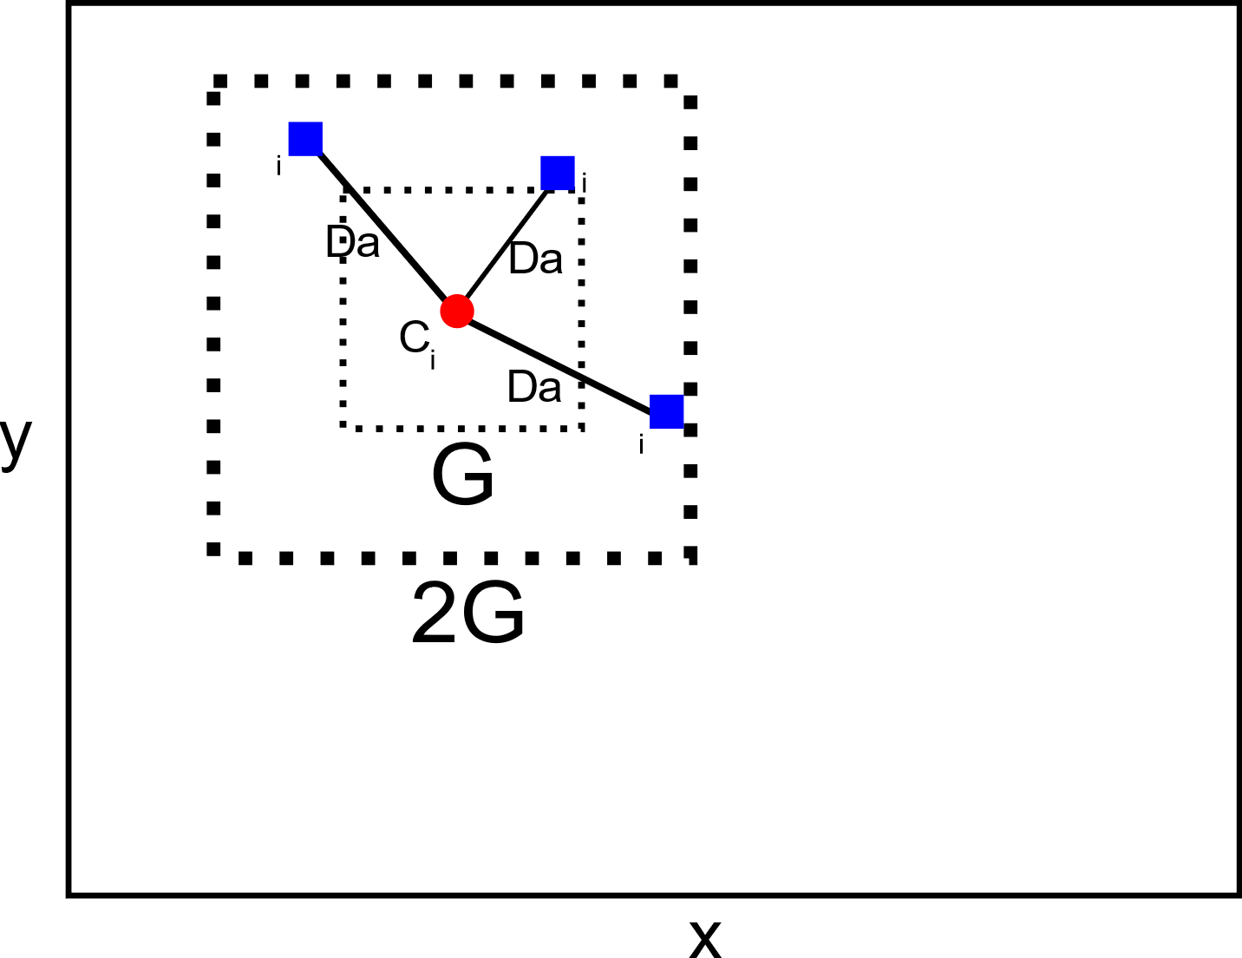

Figure 1 SLIC processing model in the allocation of a pixel $i$ in the centroid $C_{i}$ according to the distance $Da$ in the region 2G x 2G. x and y are defined as rows and columns of the image, measured in pixels. The size x, y is variable and depends on the image analyzed.

As the size of the expected Superpixel space region is approximated to G x G, the search for similar pixels is done in a 2G x 2G region around the centroid $C_{i}$. The main point to speed up the analysis is here because the processing is limited to the size of the research region reducing the calculation of $a$ and increasing the speed of the grouping in relation to the conventional analysis using K-means in which each pixel $i$ is compared with all centroid ${ C}_{i}$. At the end, after assigning all pixels to the centroid, the adjustment step is processed where for each centroid ${ C}_{i}$ the average value of its location in relation to the total grouped pixel is calculated. The SLIC method acts to minimize the error of grouping and location of pixels in relation to the centroid through testing and updating steps using the Euclidean Norm or L2 Norm.

The distance $Da$ (Eq. 1) represents processing in the CIELAB color space, whose range of values varies in combinations of $L_{i}$ which is the luminance of black to white, $a_{i}$ as being the combination of green to red and $b_{i}$ as being the combination of blue to yellow, with the pixel position in line and column (x, y). The range of CIELAB values varies with the type, size of the image and number of colors present.

SLIC based on the K-means method, being a faster iterative grouping, more efficient in using computational memory, exhibits adherence between the targeted regions and improves the performance of the segmentation algorithm.

References

ACHANTA, R. et al., 2012. SLIC Superpixels Compared to State-of-the-Art Superpixel Methods. IEEE Transactions on Pattern Analysis and Machine Intelligence, 34,11. https://doi.org/10.1109/TPAMI.2012.120.

KAVZOGLU, T., TONBUL, H., 2018. An experimental comparison of multi-resolution segmentation, SLIC and K-means clustering for object-based classification of VHR imagery. International Journal of Remote Sensing, 39, 18. https://doi.org/10.1080/01431161.2018.1506592